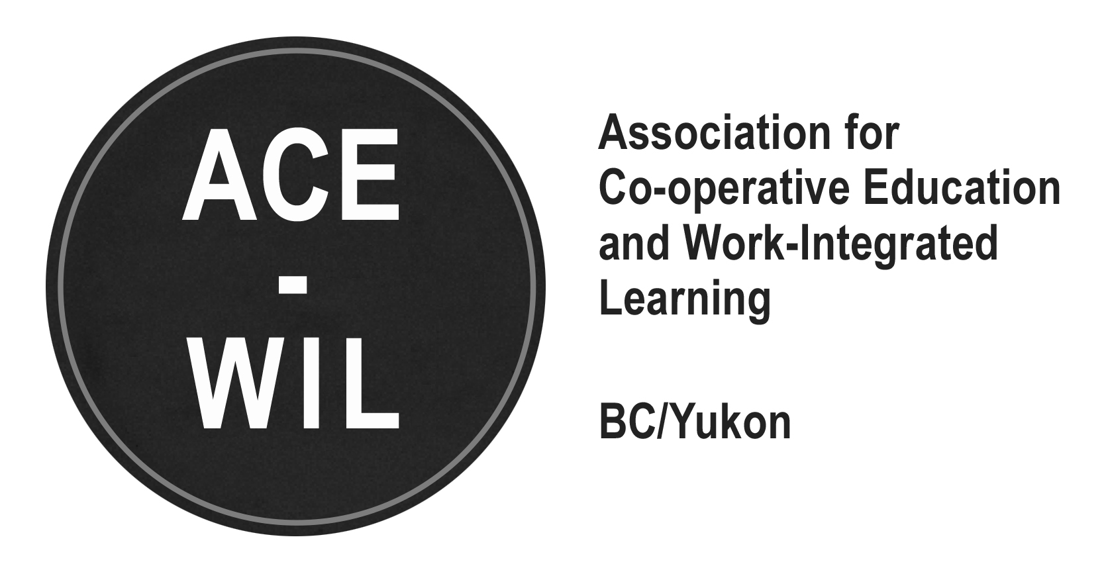

ACE-WIL AWARDS COMMITTEE
HANDBOOK

INDEX

Contents
CORE MANDATE 2
ANNUAL AWARDS 3
COMMITTEE MEMBERS 3
AWARDS TIMELINE /ACTIONS FOR COMMITTEE CHAIR 4
COMMUNICATION TEMPLATES 7
Appendix A – ACE-WIL Industry Partner of the Year Award Newsletter Release Example 7
Appendix B – ACE-WIL Industry Partner of the Year Award Newsletter Release Example 8
Appendix C - ACE-WIL Outstanding Contribution Awards Newsletter Release Examples 9
Appendix D – Congratulations follow-up email to institution 10
Appendix E - ACE-WIL Board members update 11
Appendix F – Carried Forward Action Items 12

CORE MANDATE

The Awards Committee is responsible for:
- Reviewing and updating award forms, guidelines and frameworks in reaction to changes in WIL in BC
- Enhancing the effectiveness of the awards to communicate the success of WIL across BC
- Promoting the ACE-WIL awards and nomination timelines
- Liaising with the Communications Committee to ensure most up-to-date forms and guidelines are distributed to the members and announcements are made in timely manner
- Continually improving the awards process and the awards recipients’ experiences
- Vetting nominations and determining six awards (as per below)

Annual AWARDS
- Student of the Year Awards (SOTYA)
  - Student of the Year Awards:
    - WIL Colleges, WIL Universities, Co-op Colleges and Co-op Universities
- Industry Partner of the Year Awards (IPOTYA)
- Outstanding Contribution Award (OCA)
  - Is not a required annual award
  - Request for nominations released each year

COMMITTEE MEMBERS (2020)
Committee Chair
- Natasha Dilay, Royal Roads University/ACE-WIL VP, natasha.1dilay@royalroads.ca
Members
- Sue Brown, Royal Roads University, sue.12brown@royalroads.ca
- Christy Dodds, Capilano University, cdodds@capilanou.ca
- Lianne Johnston, Douglas College, johnstonli@douglascollege.ca
- Lynda Robinson, Vancouver Island University, lynda.robinson@viu.ca
- Meg Thompson, University of Victoria, megt@uvic.ca

Partner Committee Contacts:
Communications Committee Co-chairs as contacts for web updates and newsletter releases:
Sanya Sivic sanya.sivic@ubc.ca and Sarah Gibson sgibson@tru.ca

AWARDS TIMELINE /ACTIONS FOR COMMITTEE CHAIR

Date | Activity | Comments
October/  November | Committee meeting | Basic meeting timeline to include in meeting request:  - Review previous year’s nomination package found on ACE-WIL website: SOTYA, IPOTYA and OCA  - Set nomination package submission date – usually last Monday in January @ 8am  - Establish email for package submissions  - If possible use the Chair’s department email vs individual’s email (see Appendix F for Action Item re ACE-WIL awards email)  - Review grading rubric (see Appendix F for Action Item)  - Review previous year’s newsletter message (Appendix A)  - Other standing items  - Schedule post-submission committee meeting to review nomination packages and rubrics (approx. two weeks after submission date)
November | SOTYA Nomination Package Update | Committee:  - Update nomination package as per Committee review meeting  - Update SOTYA rubric as per Committee review meeting  - Check-in with CEWIL SOTYA Committee Chairs to check nomination package and submission deadline alignment
 | SOTYA Launch | Chair:  - Request Communications Committee to:  - update ACE-WIL website with updated nomination package and dates  - Release awards submission announcement (Appendix A)
January | SOTYA  Review Process | Chair:  - Collect nomination packages and ensure they are complete  - Add nominated student names to grading rubric  - Forward nomination packages and grading rubric to committee  - Confirm scheduled conference call
January | IPOYA & OCA Launch | Committee:  - Review and update IPOYA nomination package  - Review IPOYA rubric to align with to nomination package criteria  - Establish nomination deadline (mid March)  - Update IPOYA nomination package if required  Chair:  - Request Communications Committee to:  - Upload IPOYA nomination package  - News release for both IPOYA (Appendix B) and OCA (Appendix C)  - Schedule committee conference call to review nominations and select winner within week of deadline
February | SOTYA Package Review | Committee:  - Grading of nomination packages  - Conference call (meeting set in Nov’s meeting for mid Feb):  - Review ratings of each candidate  - Identify winners/honourable mentions for each category  - Share suggestions on how to improve process for next year
March | SOTYA Notification and Awarding Process | Chair:  Pre National CE/WIL Week:  - Call or email (Appendix D)the winning and honourable mention institutions:  - let them know the results for only their student/school  - Request they notify their student  - Request they notify you once the student has been informed  - Send short follow up email to institution (Appendix D)  - Request student photo and confirm whether students prefers award sent by etransfer (confirm email) or by cheque (presented with award)  - Confirm attendance at presentation award lunch (usually at May ACE-WIL AGM lunch) (See template included further below)  - Send award winner’s preference to ACE-WIL Business Officer to process etransfer or cheque payment to the students.  - Email a general announcement of winners & honorable mentions to all ACE-WIL Board members (Appendix E)
March | IPOTYA & OCA  Package Review | Committee:  - Grading of nomination packages  - Brief conference call  - Review ratings of each candidate (if more than one submitted)
March | Announce IPOTYA & OCA | Chair:  - Update nominating institution and the Board of IPOTYA results  - Call the nominating institutions to let them know the results for Industry Partner (IP), and request they:  - notify their employer  - request a photo  - notify you once the student has been informed  - Send short congratulatory email to employer, once they have been informed by nominating institution and invite them to AGM  - Email IPOTYA recipients to Board members.  - ACA recipient to be awarded by nominator at AGM – surprise!
March | SOTYA, IPOTYA & OCA Trophy order | Chair:  - Order trophies and send invoice to ACE-WIL Business Officer:  Clarkes Recognition Products Ltd.  3974 Kitchener St, Burnaby, BC V5C 3M2  clarkesawards.com  Tel: 604.875.6231  - Artwork is on file; names and the year updated and proofs approved by Chair  Arrange for Trophies to be picked up/delivered (Heather Workman is very helpful with this: hworkman@langara.ca)  (See Action Item in Appendix F)
March | SOTYA Award Presentation | - Request Communications to prepare rough draft of press release to announce the winners/honorable mentions for  - ACE-WIL website  - ACE-WIL newsletter at start of March National WIL Month  - When released, forward email of news release to each student winner, and cc their institution and host employer
March | SOTYA Award Order | Chair:  - Order trophies and send invoice to ACE-WIL Business Officer. (You may have to cover costs and request reimbursement).  - Depending on timing you may be able to order all trophies at same time.)  - Trophies are ordered from:  Clarkes Recognition Products Ltd.  3974 Kitchener Street  Burnaby, BC V5C 3M2  clarkesawards.com  Tel: 604.875.6231  Hours: Monday-Friday 9:30am-5pm  - Arrange for Trophies to be picked up.
March | ACE-WIL Committee Report | Chair:  - Prepare Awards Committee update for ACE-WIL Annual Report
April 2020 | ACE-WIL Awards Lunch | - Confirm attendance of all winners and institution representatives will be present at ACE-WIL AGM Awards Lunch to receive award  - Arrange for trophies to be brought to Awards lunch.  - Cheques for SOTYA winners prepared and brought to awards presentation.

COMMUNICATION TEMPLATES

Appendix A – ACE-WIL Industry Partner of the Year Award Newsletter Release Example

Reminder! Student Award Nominations close on January 25

ACE-WIL BC /Yukon is looking to recognize students that participated in work-integrated learning (WIL) and you can help! The four awards recognize a college and a university student participating in co-operative education, and a college and a university student participating in other forms of work-integrated learning. Each of the four winning students, their institutions, and partner organizations will receive provincial recognition. Each winning student will receive a $500 cash award.
An ACE-WIL BC/Yukon institutional member may nominate one (1) candidate per award type (Co-op or Other Forms of WIL) with the support of the host organization/employer and approval of the student. Nominations are open now and will close on January 25th. Visit our website for more information and to download the application package.

Appendix B – ACE-WIL Industry Partner of the Year Award Newsletter Release Example
Just a reminder that the deadline to submit nominations for the ACE-WIL Industry Partner of the year award is March 13th. The Outstanding Contribution Award also has a nomination deadline of March 13th. If you intend to make a nomination for either award please submit one (1) PDF electronic document of all completed nomination materials by 8:00am on Monday, March ##, 202# via email to <Chair/Co-Chair Name> ACE/WIL Awards Committee Chair (email: <email address>)

SELECTION CRITERIA
- Significant involvement with or outstanding contributions to projects or initiatives that benefit Co-op/WIL provincially (i.e., research, sponsorship, advisory committee participation, etc.)
- Consistent record of hiring co-op/wil students and providing them with high-quality learning opportunities
- Provided student (s)with a designated mentor, additional training opportunities, professional development and critical work-place challenges
- Created additional value by allowing student to expand their original job description to match their career goals or professional interests
- Allowed students to attend decision-making meetings or become involved in challenging projects or assignments beyond the scope of the original job posting
- Provided an above-average opportunity for the student to gain skills, experiences and leadership that would surpass a typical Co-op/Wil opportunity
- Attended or supported on-campus events, including career fairs, information sessions, interview clinics, networking events, poster or debriefing sessions, etc.

EVALUATION CRITERIA
- Contribution to Co-operative Education and or Work Integrated Learning – 15 points
- supporting on-campus events, either financially or with in-kind support, attending information sessions, career fairs, interview clinics, networking events, guest speakers, speaker panels, attending poster or debriefing sessions, etc.
- Quality of the experience – 10 points
- Link with education, depth of work experience, level of responsibility, access to challenging projects or assignments, etc.
- Provision for a professional growth experience – career, competency and/or academic development – 10 points
- Professional Development, memberships or participation in professional associations, etc.
- The mentoring relationship provided to the student during the work term – 10 points
- providing networking and informational interview opportunities with other professionals, providing career development advice and guidance, etc.
- Evaluator assessment and recognition of additional qualities of nominee – 5 points

Visit the ACE-WIL Industry Partner of the Year page on the ACE-WIL website for more information and to download the nomination package

Appendix C - ACE-WIL Outstanding Contribution Awards Newsletter Release Examples

The Outstanding Contribution Award recognizes those ACE-WIL members for significant contributions or initiatives in promoting and developing the quality of work integrated learning in British Columbia.
Selection Criteria:
The ACE-WIL Awards Committee will consider the below criteria of the nominated practitioner or faculty:
- A minimum of three years involvement with ACE-WIL Board or a committee(s)
- Significant involvement to projects or outstanding contributions to to initiatives that benefit work integrated learning
- Substantial contributions in the field of work integrated learning, including research, teaching, program development, and/or educational administration

Visit the ACE-WIL Outstanding Contribution Award page on the ACE-WIL website for more information and to download the nomination package

Appendix D – Congratulations follow-up email to institution

Initial email:

I was looking forward to calling all of the institutions who submitted student award nominations; however, with most people working from home during the pandemic, I have elected to email the ACE-WIL contacts from the nomination form.
The ACE-WIL Awards Committee would like to thank <institution name> for submitting a nominee for the <aard name>, and a huge congratulations to your student for being the selected nominee:
CO-OP UNIVERSITY - Student of the Year Award Recipient: <student name>. Please relay the Award Committee’s congratulations.
During your follow-up with <student name>:, would you please confirm these details:
- How would s/he like to receive their $500 cash award - cheque or email money transfer?
- Will he be able to attend the virtual ACE-WIL AGM in May for the formal award presentation (specific date, time, and virtual location details to follow)?
- Can he please submit to you a quality headshot photo for the ACE-WIL newsletter announcements and on the award recipient webpage?
Finally, could I please ask you to confirm with me once you have spoken your students.
Thank you, and, again, congratulations to…
OR

Follow-up email:

It was great speaking with you yesterday afternoon and congratulations once again to you, and <student name> for being selected as the <University Winner for the 2019 ACE-WIL Student of the Year Award>

As discussed, here are the details that you can relay to <student name>: about the award and please let me know once you’ve had a chance to speak with <student name>:
- <student name and institution> has been selected as the <University Winner for the 2019 ACE-WIL Student of the Year Award>
- $500 cash award (please confirm if <student> would like a cheque or email money transfer to receive the award)
- Please extend an invite to <student> to be our guest at the ACE-WIL AGM in May for the formal award presentation. The lunch will be at <Location of Event> (specific time/ location details to follow). It would be wonderful to have you or another representative from <student’s institution> attend the lunch to present the award to <student>.
- Please let <student> know all ACE-WIL student award winners will be announced via our member newsletter and posted on ACE-WIL website within the next few weeks.

Please request a student headshot photo for the announcements.

Thank you, congratulations once again

Appendix E - ACE-WIL Board members update

Dear ACE-WIL Board Members

The Awards Committee is pleased to announce the <year> ACE-WIL award recipients.

WIL COLLEGES
Recipient: <Student name>, <Institution name>
Honourable Mention: <Student name>, <Institution name>

CO-OP COLLEGES
Recipient: <Student name>, <Institution name>
Honourable Mention: <Student name>, <Institution name>

WIL UNIVERSITY
Recipient: <Student name>, <Institution name>
Honourable Mention: <Student name>, <Institution name>

CO-OP COLLEGES
Recipient: <Student name>, <Institution name>
Honourable Mention: <Student name>, <Institution name>

The institutions of the awards have been contacted. The ACE-WIL member representative has been requested to reach out to their students to congratulate them and invite them to attend the May AGM to be acknowledged for their award.

The details of each recipient have been passed along to the Communications team for release in upcoming newsletters and to the Business Officer for the transfer of the awards funds. The award plaques will be ordered again through Clarkes Recognition Products Ltd. in Burnaby.

Best regards,

Appendix F – Carried Forward Action Items

- Redevelop existing rubric to better reflect the diversity of WIL students, experiences, and education frameworks. (Meg and Sue)
Considerations:
- Equity-seeking minority groups
- Impact on community/ies
- Impact on fellow students (reducing the emphasis of the benefit to institutions)
- Elevating experiences in new environments/pushing personal & professional boundaries

Brought forward from 2020 review process:
1) Revisit the rubric to align with the nomination packages
2) Re-introduce the resume as part of the nomination package
3) Re-evaluate the weighting of the GPA-but still include the transcripts
6) Align the Awards committee deadline for final selection decision with the National Co-op Week
7) Lynda has agreed to review the CEWIL award and compare to the ACE-WIL Award and report back to the committee.

- Include grading rubric on website for nominators to reference nomination

- Have an ACE-WIL Awards email for confidential submission and awards questions from members (ie. awards@ace-wil.ca)

- Formalize process by which this committee recommends adaptation/changes to the awards/policy/process, etc., to the board
  - Add process to Awards Committee Handbook

